Lab 06 - Implement Traffic Management

Task 1: Provision the lab environment

We are deploying four virtual machines into the same Azure region.  
Two will reside in a hub virtual network, while each of the remaining two will reside in a separate spoke virtual network.

First we open the PowerShell in Azure and we upload the template.json and parameters.json files,   
we change the password in the parameters file and run

$location = 'eastus2' to create the first resource group that will be hosting the lab environment

$rgName = 'az104-06-rg1' to create the resource group name

New-AzResourceGroup -Name $rgName -Location $location   
 create the resource group in your desired location.

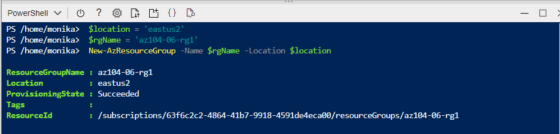

Next we create the three virtual networks and four Azure VMs into them by using the template and parameter files that we previously uploaded

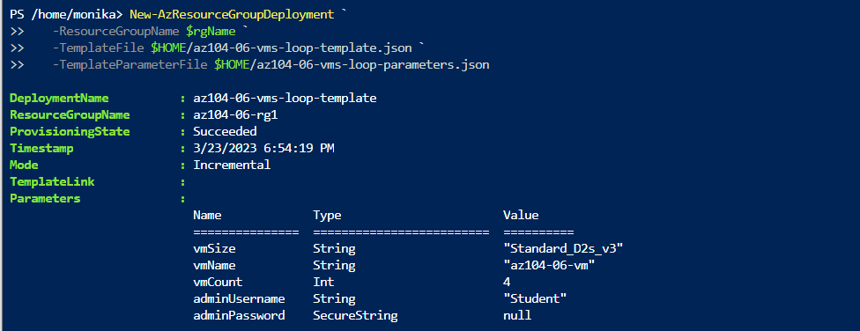

and   
install the Network Watcher extension on the Azure VMs after they are deployed.

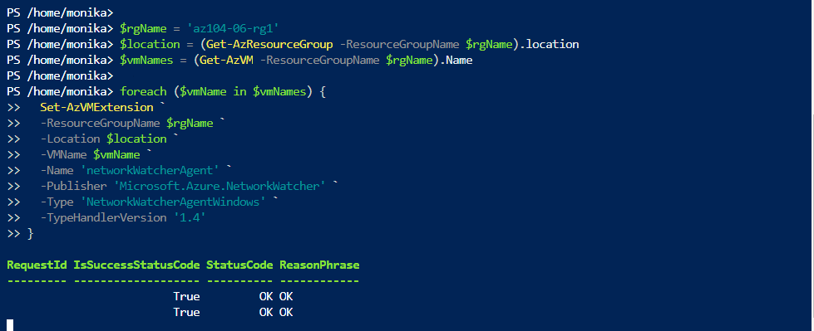

Task 2: Configure the hub and spoke network topology

In this step we will configure the local peering between the virtual networks and create a hub and spoke network topology.

First we can check the virtual networks that were already created in the previous step

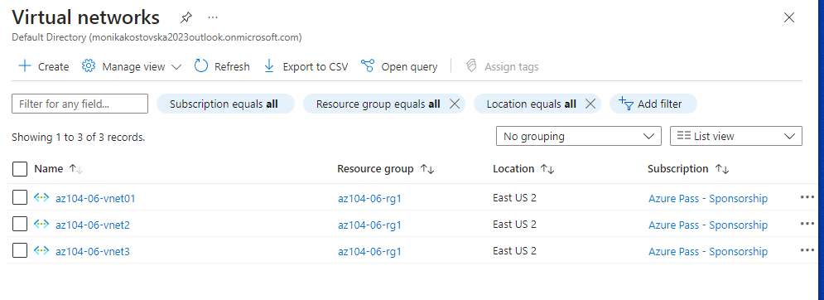

We collect the ID properties from the virtual networks – in the properties of each virtual network  
We add peering on the first virtual network and input the provided settings   
by submitting this step establishes the two local peerings   
one from az104-06-vnet01 to az104-06-vnet2   
and the other from az104-06-vnet2 to az104-06-vnet01

In the next step we will do the same with the third virtual network - establish the two local peerings   
one from az104-06-vnet01 to az104-06-vnet3  
and the other from az104-06-vnet3 to az104-06-vnet01

By finishing this step we set the hub and spoke topology

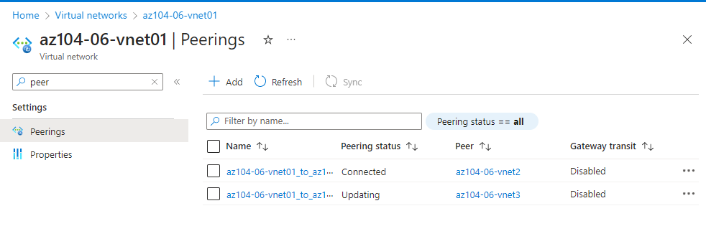

Task 3: Test transitivity of virtual network peering

We open up Network Watcher blade and navigate to connection troubleshoot to initiate a check with the provided settings in the lab  
This is how the check result will look like:

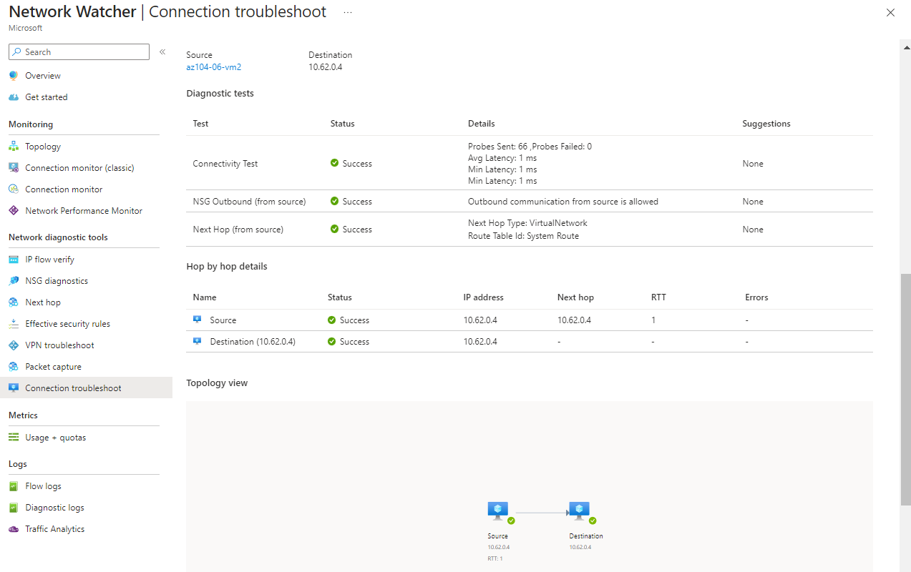

The connection was direct with no intermediate hops in between the virtual machines.   
We repeat the same check with VM 3

The next step is providing settings that will fail because the virtual networks are not peered with each other

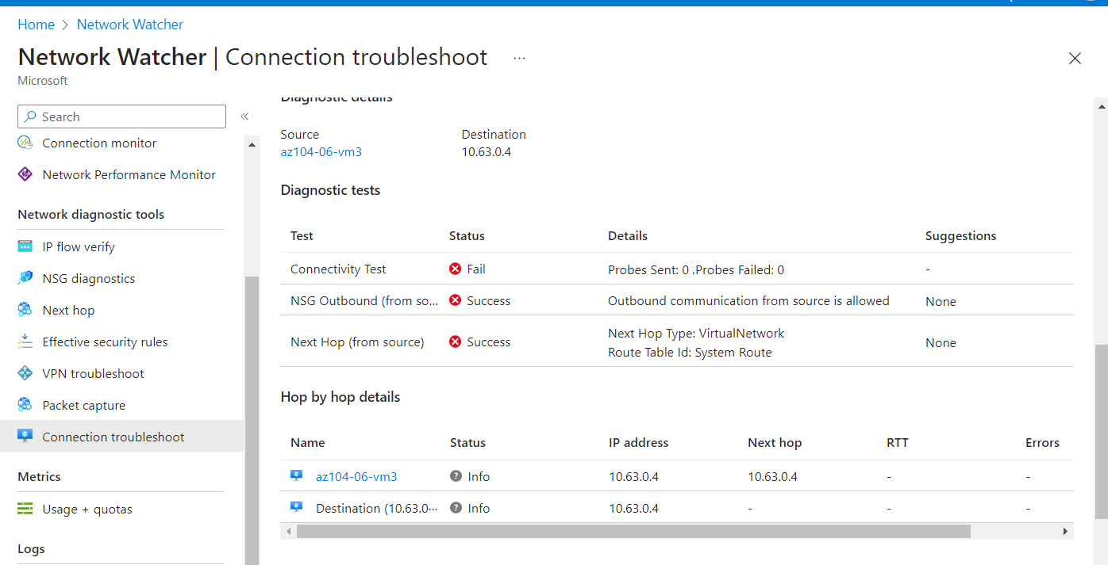

Task 4: Configure routing in the hub and spoke topology

In this task we are going to configure and test the routing between the virtual networks by enabling IP forwarding

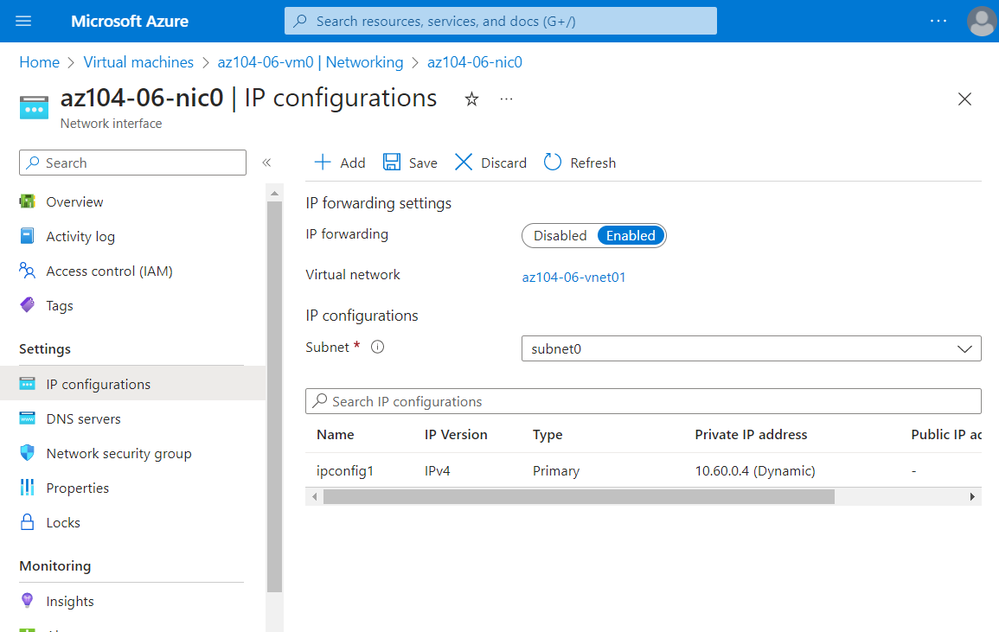

We must enable IP forwarding so the VM can function as a router between two virtual networks

In the next step we will need to configure operating system so the VM can be routing  
We run the provided command in Run command script

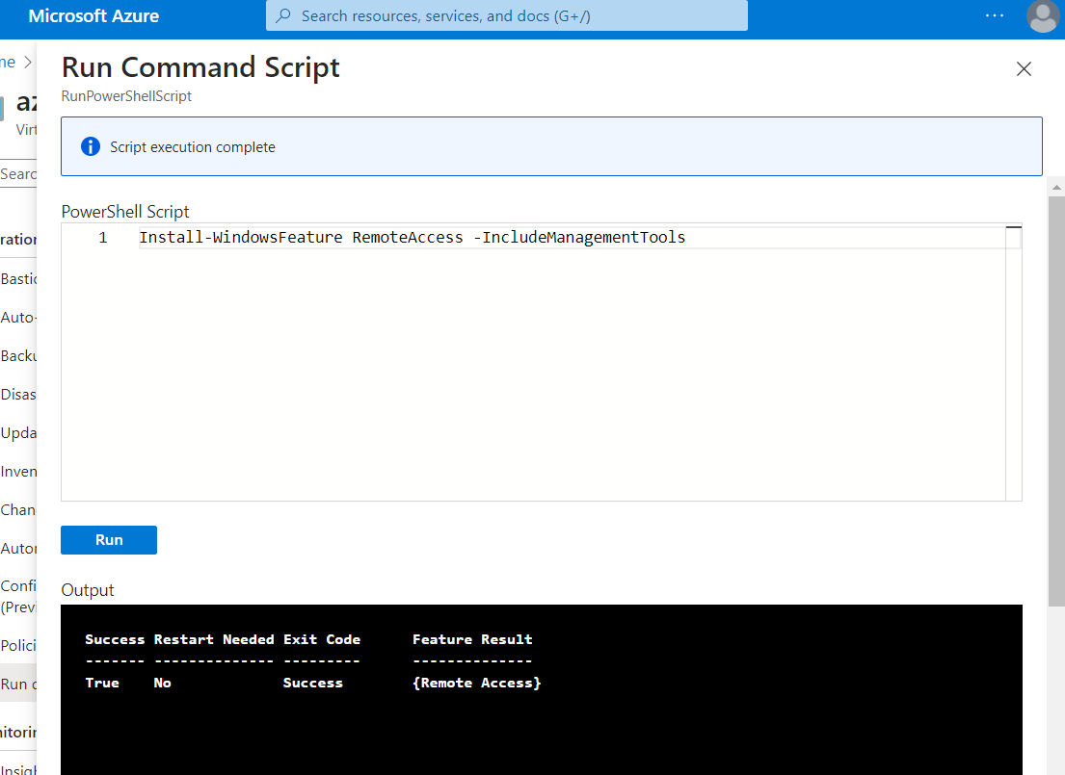

And another command to install the routing role service.

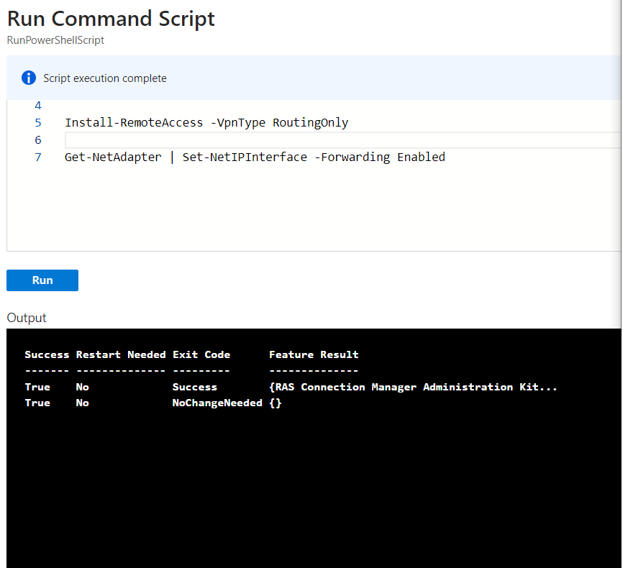

Next we’ll create and configure user defined routes

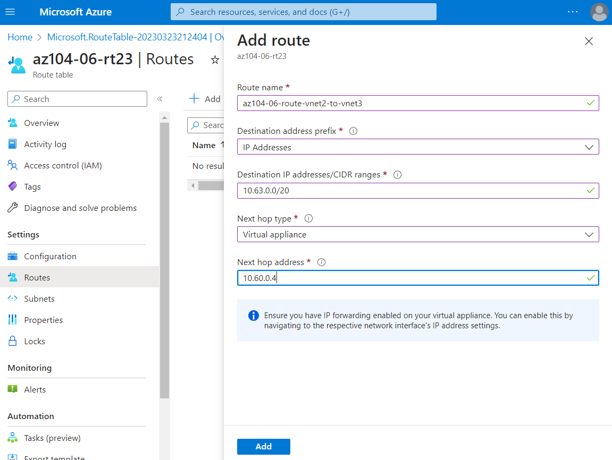

After the routes are created we are going to subnets and add associate  
This way we’ll associate the route table with the subnet

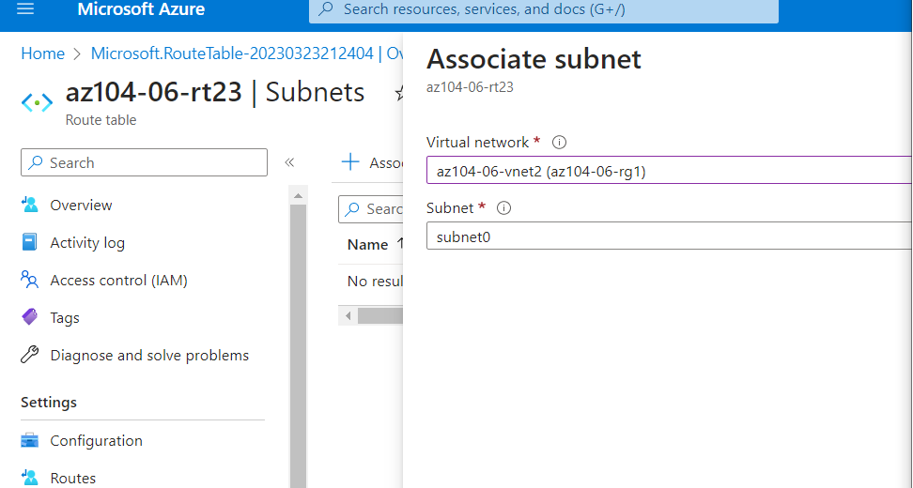ing subnet:

Create a new route table

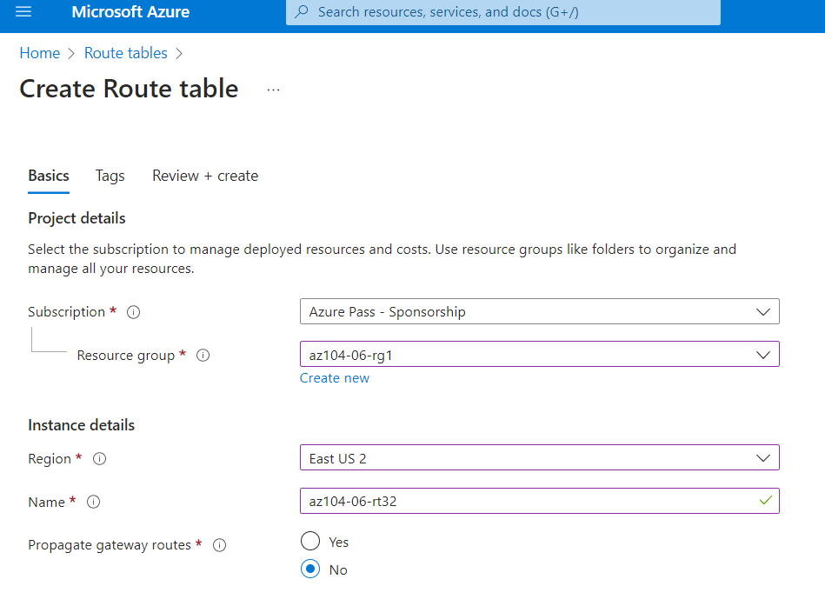

On the newly created route table we will add routes

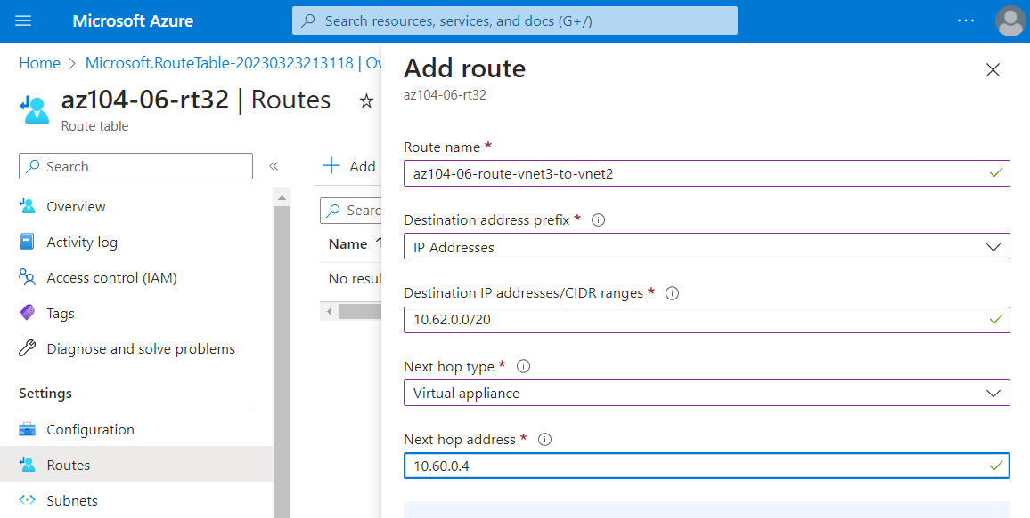

And associate the route table  with the following subnet:

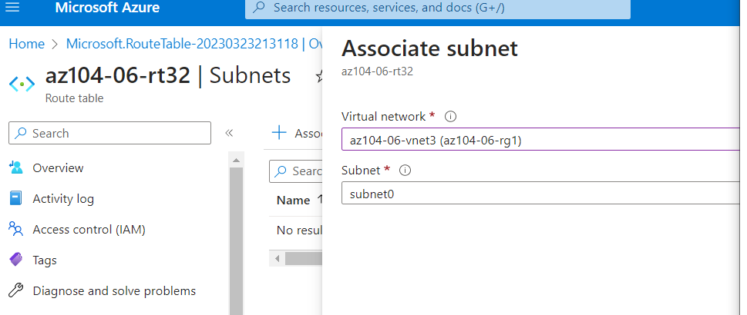

**Network Watcher - Connection troubleshoot** blade, initiate a check

#### Task 5: Implement Azure Load Balancer

in front of the two Azure virtual machines in the hub virtual network.

First we are creating Load Balancers with the provided settings  
adding IP configurations

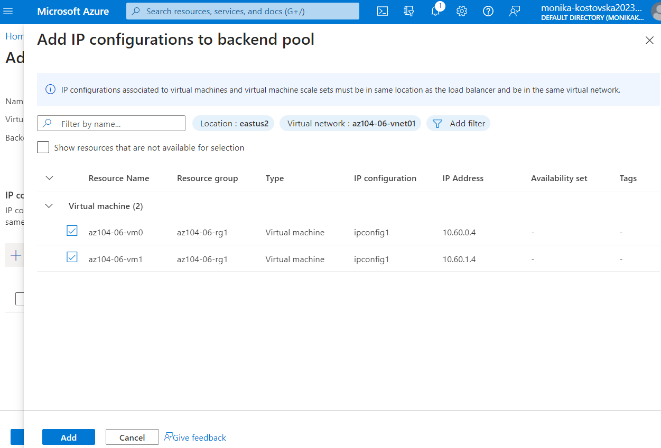

Set up a load balancing rule

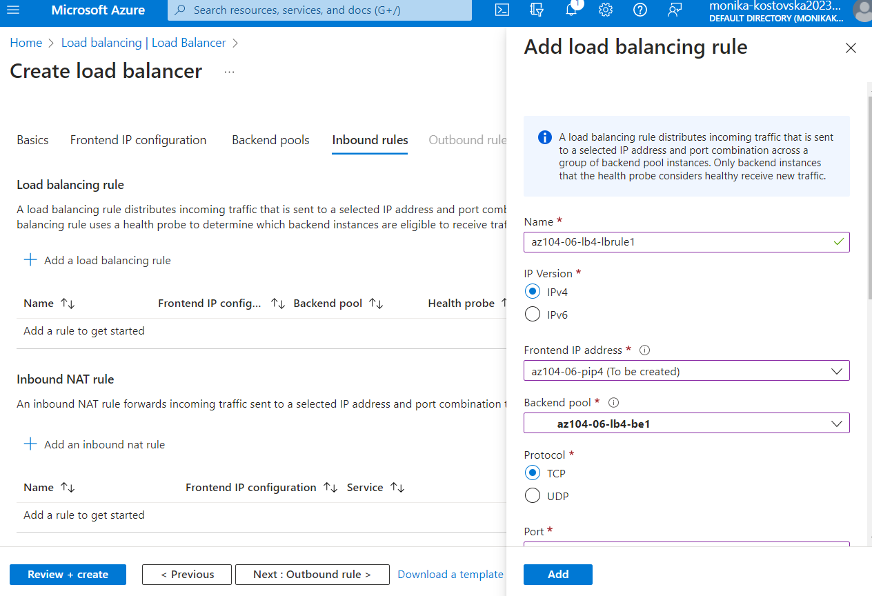

Take the IP address from the Frontend configuration so we can run it in another tab

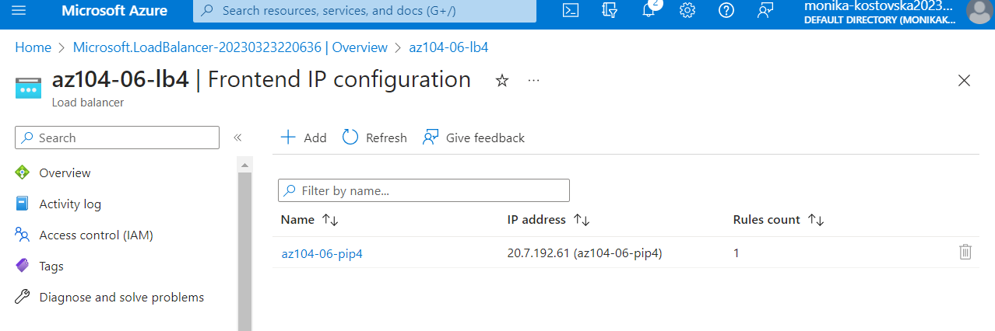

The first time we open the IP address we can see that its on VM0, after we refresh or open another tab no matter if it’s incognito as in the picture, the virtual machine will switch to VM1

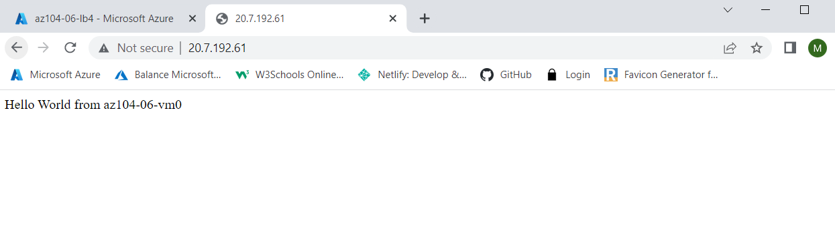

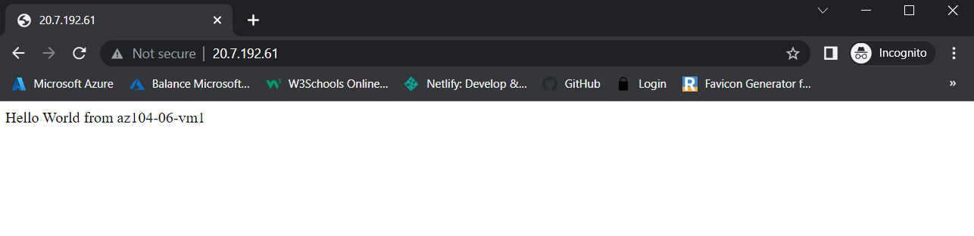

#### Task 6: Implement Azure Application Gateway

In this task we will implement an Azure Application Gateway in front of the two Azure virtual machines in the spoke virtual networks.

We start by adding a subnet to the virtual network  
This subnet will be used by the Azure Application Gateway instances

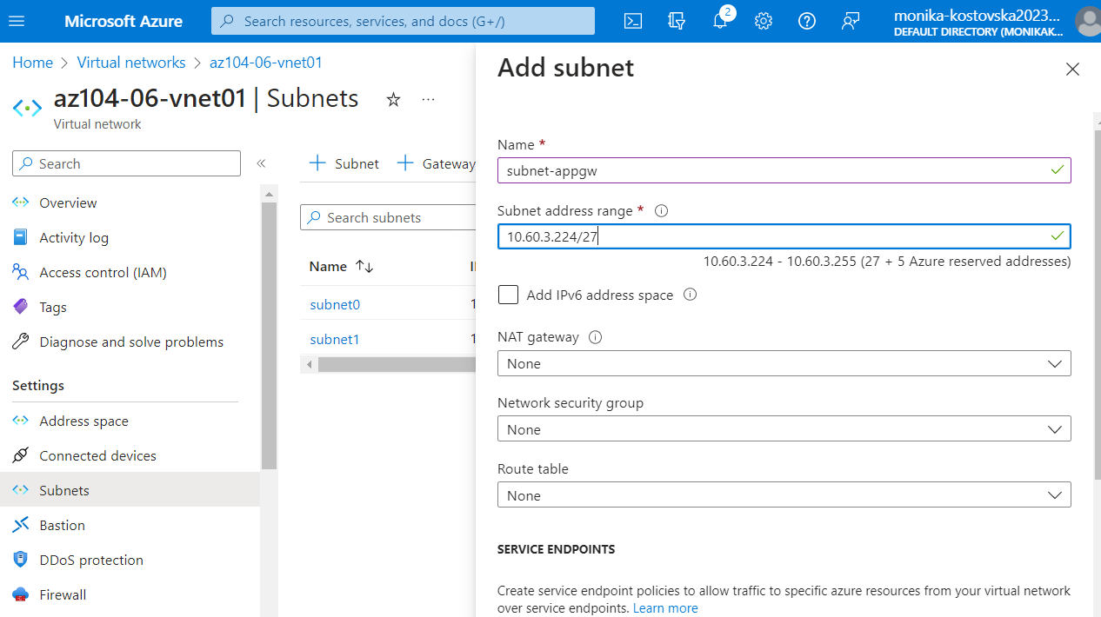

Than we create Application Gateways

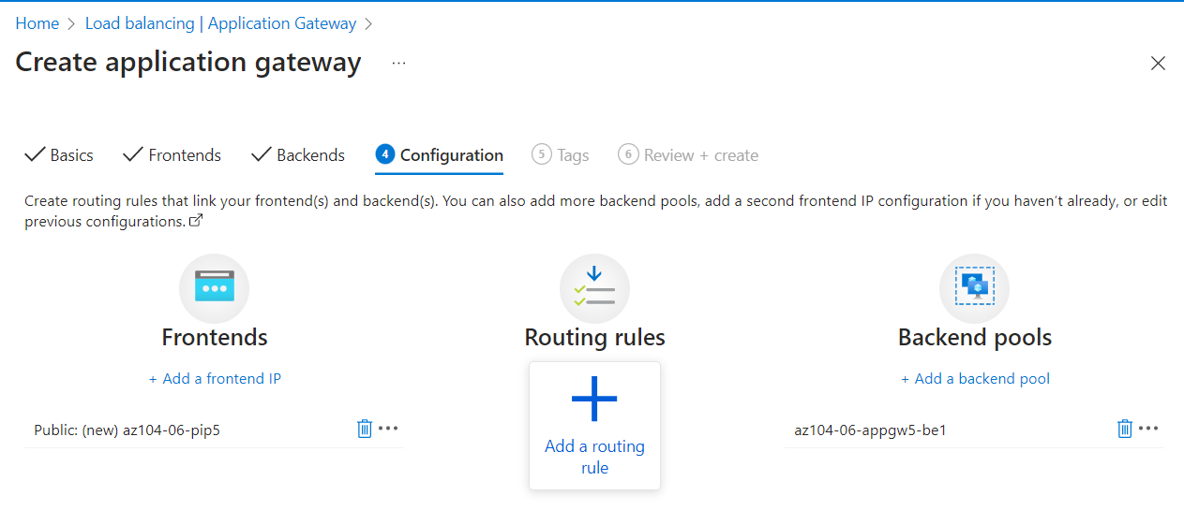

After the gateway is created we’ll get the public IP address and open it in another tab to see what will happen

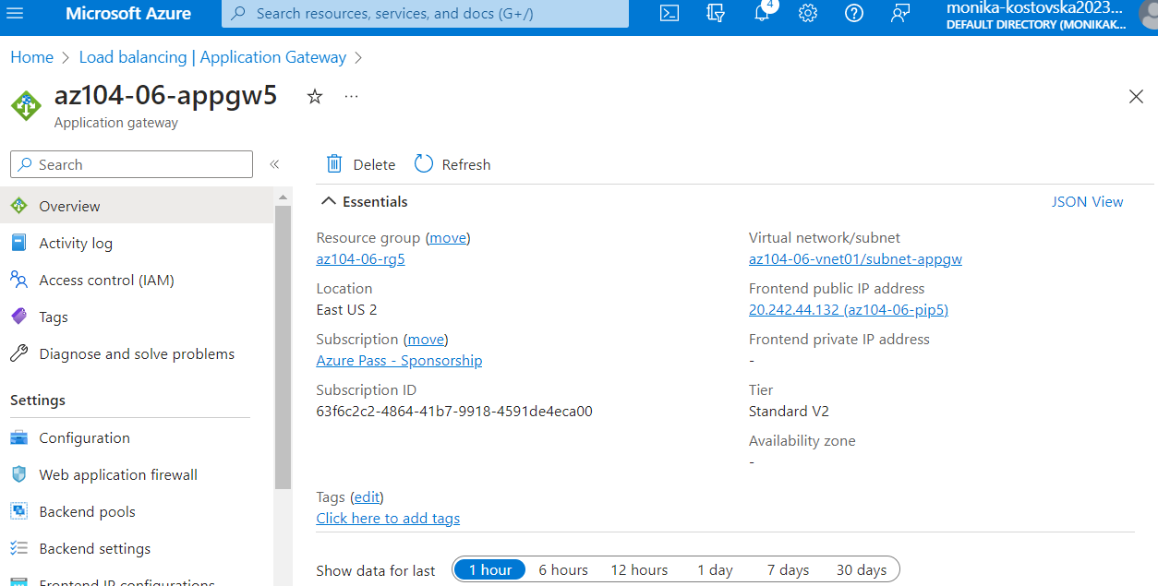

After we run the IP address we verify that Hello World will appear from the VM3, after we refresh the VM will change to another VM ( VM2)

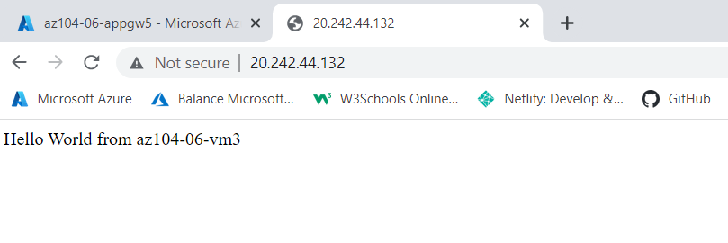

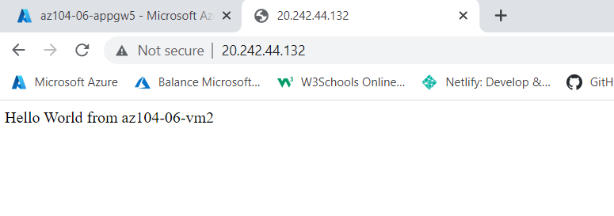

After I finished this exercise I checked the Topology again and this is how it looked like

